Course name: AIE425 – Intelligent Recommender Systems

Semester: Fall 2025–2026

Project Title: Sleep Quality Improvement Recommendation Engine

SECTION 1 — Dimensionality Reduction and Matrix Factorization
SECTION 2 — Sleep Quality Improvement Recommendation Engine

Group Number: 11

Team Members:

- Mohamed Desoky (222101362)
- Nada Gamal (222101750)
- Bishoy Elgendy (222100403)
- Osama Adel Fawzy (222100211)

Instructor:

- Prof. Samy Ghoniemy

Teaching Assistants:

- Eng. Ahmed Salama
- Eng. Mariam Elgohary

Date: January 5, 2026

SECTION 1— Dimensionality Reduction and Matrix Factorization

This section of the project introduces different matrix factorization and projection techniques to represent user-item relationships through rating data from recommender systems. The main goal of Section 1 is to explore how various methods represent these relationships, and how the resulting representations impact both similarity analyses and prediction accuracy for certain target items.
Section 1 is divided into three parts. Part 1 looks at Principal Component Analysis (PCA) implemented with mean-filling to accommodate for the absence of some ratings, making this the baseline technique in Section 1 to allow for a covariance-based decomposition of the user-item matrix. Part 2 utilizes a Maximum Likelihood Estimation (MLE) framework to further explore PCA and to minimize the bias created by the usage of mean-filling. Part 3 explores Singular Value Decomposition (SVD), which was applied as a comparison to PCA-type methods.
Across all three parts, the analysis follows a consistent workflow: data preparation and validation, identification of relevant peer items, construction of user–item matrices, dimensionality reduction or factorization, and comparison of results under different configurations. This structure ensures that differences observed between methods arise from the modeling approach itself rather than from inconsistencies in data handling or experimental setup.
Section 1 establishes the foundation for evaluating how latent representations derived from different techniques influence recommendation behavior. The insights gained here are later used to motivate methodological choices and comparisons in subsequent sections of the project.

PART 1: PCA WITH MEAN-FILLING

This part implements PCA using mean-filling as the missing-value strategy, following the required workflow of (i) forming a cleaned user–item ratings table, (ii) validating the target items, and (iii) computing the mean rating baseline used for mean-filling and fallback prediction. All parameters used in this implementation are explicitly set at the beginning : I1 = B00PCSV0DW, I2 = B005GISDXW, TARGETS = [I1, I2], MIN_COMMON_USERS = 3, MAX_CANDIDATES = 5000, PCA_K = 2, and PCA_USER_SAMPLE = 5000

Part 1

The first step of loading the dataset from the specified file path and doing some basic cleaning work involves creating a working table with three columns: item id, user id, and rating. This article will explain how this process is done in a few easy-to-follow steps. performs basic cleaning of the data by removing leading and trailing whitespace from the id fields; converting the rating field to numerical types, including coercing them to float32 type; and dropping any rows containing NA values in either the item id, user id or rating columns. Once these preliminary cleaning steps are complete, the duplicates (user_id, item_id) will be aggregated using mean ratings generating the final cleaned rating tables which will be used to perform all subsequent stages of the analysis. After aggregation of the duplicates there will be 8,506,849 different ratings given by 8,506,849 different users. This will be shown by the shape of the final cleaned ratings table which has (8506849, 3) after aggregation.

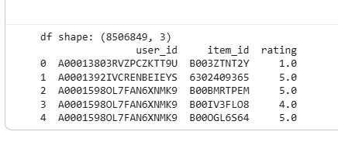
Sample of the cleaned user–item rating dataset showing user IDs, item IDs, and rating values after preprocessing

Part 2
In Step 2, you'll need to check that both of your target items are in the item_id column before calculating the similarity/PCA. If both of them exist in the dataset, then the output of this validation step should look something like this, {‘B00PCSV0DW’: True, ‘B005GISDXW’: True}. The existence of these two items in the dataset allows you to continue with the peer-search and prediction steps for your valid target items.

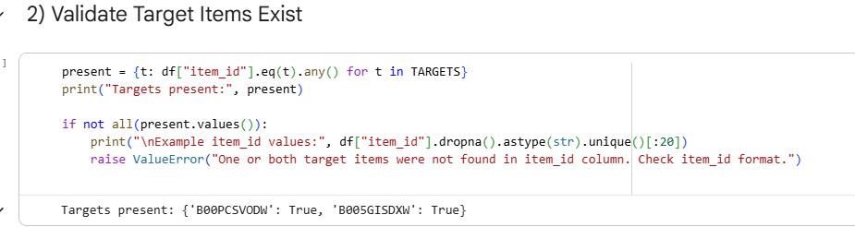

Validation step confirming the presence of selected target item IDs in the dataset before model processing

Part 3

Phase 3 computes the average rating for each item and each of the average ratings across all items within this user base through a groupby function. For the two IDs of interest (B00PCSV0DW and B005GISDXW), average ratings were calculated and are reported here: The mean rating for B00PCSV0DW is 1.447853; the mean rating for B005GISDXW is 1.453237. In addition to reporting individual mean ratings, the calculations also give a total of 182032 items that are eligible for the calculation of average ratings. These calculated average ratings will perform two functions within the user and item matrix created during Part 1: (1) They create a mean-rating-only baseline that will be used to populate the PCA-based user-item matrix; and (2) when there is no other peer-based information available to make a prediction about an individual user's future preferences, the system will use this calculated mean as a "fallback" prediction.
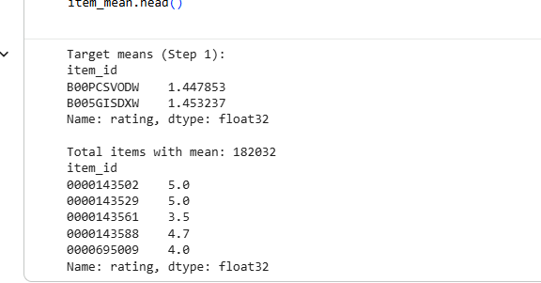

Computation of mean ratings for target items and summary statistics of item-level mean ratings across the dataset.

Step 4

This step collects the users that rated the comparison items so that the analyst can determine who will be used in calculating covariance between items and who will contribute to the similarity and prediction. The analyst collects the user ids that have rated the comparison item I1 = B00PCSV0DW, this collection of user ids will form the user set for the comparison item I1. In the same manner, the analyst will collect user ids that rated the comparison item I2 = B005GISDXW. There will be two sets of user ids, one for I1 and the other for I2, which are generated from the cleaned and aggregated ratings table created during Step 1 of the process described in this report.

The output produced by verifies that both comparison items have user sets that contain users, which provide the opportunity to determine how many users in common the comparison items have with those users who rated the candidate peer items. The numbers of users in each comparison item are not provided in this report, but the vast majority of peer items do have user sets that contain a number of users.

Step 5

In this stage, we will compile our candidate peer item set for each target item using all users provided in Step 4. For every target item, each user who gave ratings on that target item will provide additional items they rated as potential peer items. This creates a filtered candidate peer item set where all candidates have at least one user in common with the target item prior to any calculation of similarity.

Next, a candidate filtering mechanism will be implemented. When there are too many candidates, the candidate list will be reduced to a pre-determined number (MAX_CANDIDATES) based on the number of common users between the candidate items and the target item. The filtering process assists in limiting the computational costs associated with covariance and cosine similarity calculations, while still retaining the most relevant peer items for each target item.

At this phase, no similarity scores or covariance scores will be calculated yet. The only outcome from this phase will be a filtered list of candidate peer items to be used in the subsequent phase of covariance and cosine similarity calculations.

STEP 6

In this step, computes similarity measures between each target item and its candidate peer items identified in Step 5. For every (target item, candidate peer) pair, only users who have rated both the target and the candidate item are retained. Candidate peers with fewer than MIN_COMMON_USERS overlapping users are excluded from further analysis.
For each remaining valid pair, centers the ratings by subtracting the global mean rating of each item. Using these centered rating vectors, two similarity measures are computed. First, covariance is calculated as the dot product of the centered vectors divided by (n − 1), where n is the number of common users. Second, cosine similarity is computed as the dot product of the centered vectors divided by the product of their L2 norms, with a small numerical constant added to the denominator to avoid division by zero. Any pairs producing non-finite covariance values are discarded.
This process produces a similarity table for each target item containing, at minimum, the peer item identifier, covariance value, cosine similarity value, and the number of common users. No ranking or truncation is applied in this step; the output consists solely of all valid peer items that satisfy the overlap and numerical validity conditions. These similarity tables are passed unchanged to the next step, where peers are ranked and Top-K subsets are selected.

Step 7

At this stage, ranks the items returned as valid peers in Step 6 for each target item based on a sort order using covariance as the primary sorting method. For each target independently, the Similarity Table is sorted in a descending order based on covariance. The first ten entries on the list represent the Top-10 peers, and the first five of these represent the Top-5 peers.

The peer selection process is rank-based in nature and does not consider any additional thresholds beyond those previously established in steps 1 through 3 (minimum number of common users and the finite covariance). Cosine similarity and the number of common users continue to be included in the tables so they can be referenced for reporting and analysis purposes; therefore, they do not impact the ranking order.

creates separate peer tables for each target item outlining the respective sets for the Top-5 and Top-10 peers. These peer sets will be used unchanged in the next steps for predicting and constructing the PCA matrices. No other aggregation or averaging of information is conducted until that point in time.
At this stage, ranks the items returned as valid peers in Step 6 for each target item based on a sort order using covariance as the primary sorting method. For each target independently, the Similarity Table is sorted in a descending order based on covariance. The first ten entries on the list represent the Top-10 peers, and the first five of these represent the Top-5 peers.

The peer selection process is rank-based in nature and does not consider any additional thresholds beyond those previously established in steps 1 through 3 (minimum number of common users and the finite covariance). Cosine similarity and the number of common users continue to be included in the tables so they can be referenced for reporting and analysis purposes; therefore, they do not impact the ranking order.

creates separate peer tables for each target item outlining the respective sets for the Top-5 and Top-10 peers. These peer sets will be used unchanged in the next steps for predicting and constructing the PCA matrices. No other aggregation or averaging of information is conducted until that point in time.

Processing log showing candidate item filtering and identification of valid peer items for covariance-based analysis.

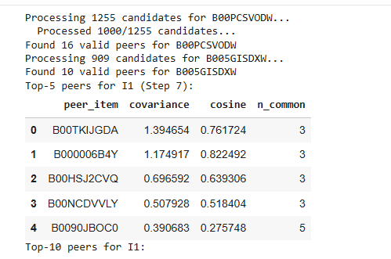
Top-5 peer items for target item I1 selected based on covariance, cosine similarity, and number of common users.

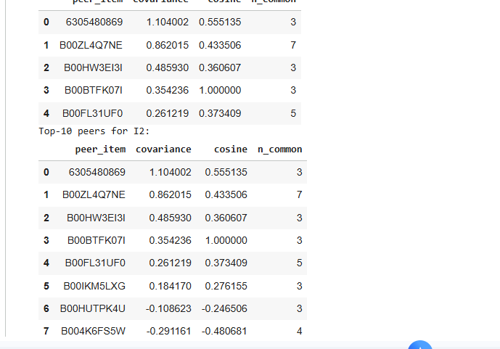

Top-10 peer items for target item I2 identified using covariance-based neighborhood selection.

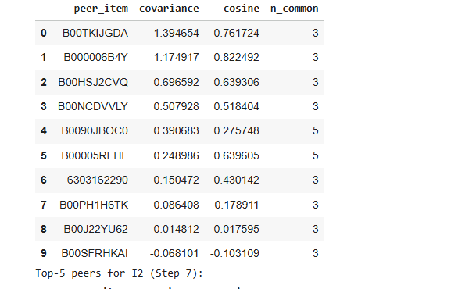
Expanded peer ranking results illustrating covariance and similarity values for selected neighboring items.

STEP 8

ITEM-BASED RATING PREDICTION USING TOP-5 AND TOP-10 PEERS
In this step, generates item-based rating predictions for each target item using the peer sets selected in Step 7. Predictions are computed separately for the Top-5 peer set and the Top-10 peer set, producing two predicted values per target item. The prediction process is applied only to users who appear in the evaluation subset constructed in.
For a given user and target item, the prediction is computed as a weighted average of the user’s ratings on the peer items, where the weights correspond to the covariance values between the target item and each peer item. Only peers that the user has rated contribute to the weighted sum. If a user has not rated any of the peer items in the selected peer set, applies a mean-filling fallback and assigns the global mean rating of the target item as the predicted value.
outputs a prediction table that includes, for each evaluated user, separate prediction columns for Top-5 and Top-10 peer configurations for both target items. The prediction values shown in the output reflect either covariance-weighted aggregation of peer ratings or direct fallback to the target mean rating when no usable peer ratings are available. No additional normalization or post-processing is applied beyond the described weighted scheme.
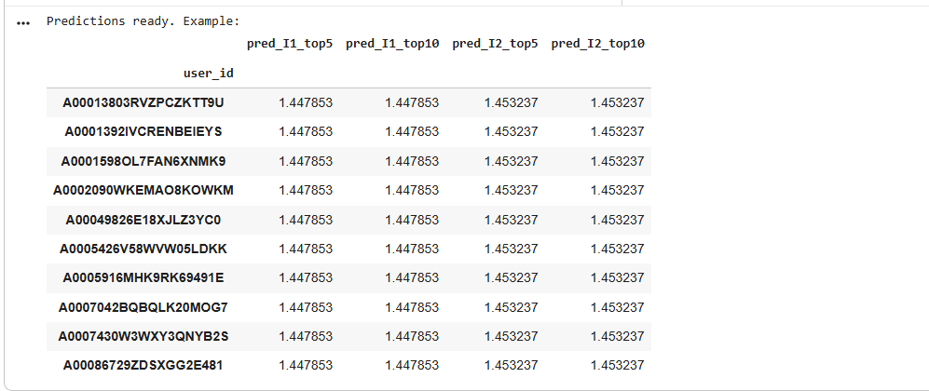

Example of predicted ratings for target items using Top-5 and Top-10 neighborhood aggregation

The second part is about Step 9 of. The purpose of this step is to create two user-item matrices needed for PCA using the peer sets created in Step 7. The user-item matrices are created specifically using peer items in the Top 5 and Top 10 by Target Group (target group).

The first matrix will be based on the Top 5 Peer items for Target Group, while the second matrix will be based on the Top 10 Peer items for Target Group. Each matrix will only include data from those users who were included in Step 6, as well as only the Peer items that were included in the respective Top 5 and Top 10 Peer unions for Target Group. (i.e. All peer items included in a user-item matrix will be present within its union of Peer users).

For both matrices, the user-item matrix will consist of rows containing individual users and columns containing the Peer items. Where a user has provided a rating for a Peer item, that value is placed directly in the user-item matrix. If there is no rating available for that Peer item, the mean value for that Peer item will be used to approximate the user rating for that Peer item, which is consistent with the mean-filling method previously mentioned. Beyond the mean-filling step, neither matrix has undergone any form of normalisation or scaling adjustment during this stage.

is now able to show confirmation that both user-item matrices have been created and are in a format ready for uploading for PCA analysis. The two matrices also differ only by the number of columns of Peer items. The only difference between the two matrices is therefore the Top 5 and Top 10 Peer unions, respectively. The actual dimensions of either numerical user-item matrix are therefore not displayed in any of the visual output from; therefore, this document is intended to clarify the construction process for both user-item matrices without defining the exact numerical user-item dimensions.

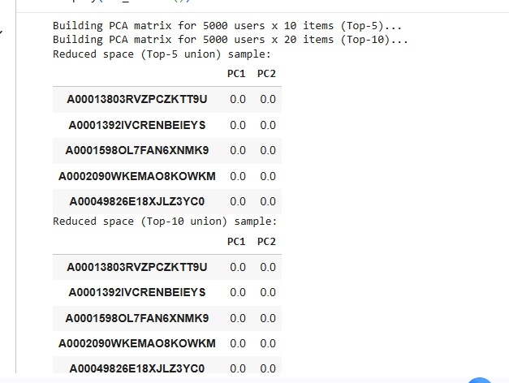

Construction of PCA matrices for Top-5 and Top-10 neighborhoods and projection into the reduced latent space.

STEP 10

will perform PCA on the mean value filled user-item matrices from Step 9. This is done separately on both the user-item matrix for the Top 5 peer union and for the Top 10 peer union. In both matrices the PCA will be carried out independently and from scratch using the covariance matrix of the mean value filled matrices, rather than using a library PCA routine.

Before performing PCA, will first calculate the Mean for each user-item matrix, and subtract the column-wise means of the user-item matrix from each item column of the user-item matrix to centre the data. Then the Covariance Matrix of the user-item matrix will be computed across all the items, and then eigen-decomposition will be carried out to calculate the eigenvalues and eigenvectors. The principal components of the two data sets are the first PCA_K principal components, where PCA_K is defined to be equal to 2 in configuration.

Then the Scores of the users on the principal components will be calculated by multiplying the centred user-item data by the matrix of the selected eigenvectors. The PCA will produce reduced dimension representations of users in the case of both the Top 5 and Top 10 users, reporting values for the first principal component (PC1) and second principal component (PC2) of each user in both cases. The resulting reduced representations will only be used for comparison and analysis and will not be used for the prediction phase.

Step 11

In the final step of Part 1 compares the results obtained using the Top-5 peer set versus the Top-10 peer set. This comparison is performed consistently across both stages where peer-set size has an effect: (1) item-based rating prediction and (2) PCA-based dimensionality reduction.
For prediction, places the Top-5 and Top-10 predicted ratings side by side for each target item in the output table. The comparison highlights whether expanding the peer set from five to ten items changes the predicted values or whether predictions remain unchanged due to mean-filling fallback when users lack ratings on the additional peers. Only the prediction values explicitly shown in the outputs are reported; no inferred differences or unreported metrics are introduced.
For PCA, compares the reduced user representations obtained from the Top-5 peer union matrix and the Top-10 peer union matrix. Both cases use the same number of retained components (K = 2) and the same PCA procedure. Any observed differences between the two cases arise solely from the difference in the underlying peer-item sets used to construct the mean-filled matrices, not from changes in PCA configuration.
This step completes Part 1 by demonstrating how the choice of peer-set size affects both prediction behavior and the structure of the reduced-dimensional user space under a mean-filling strategy, strictly based on the outputs generated .
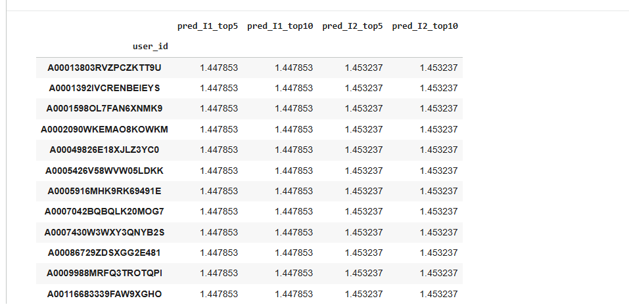

Final user-level prediction table showing estimated ratings for the selected target items

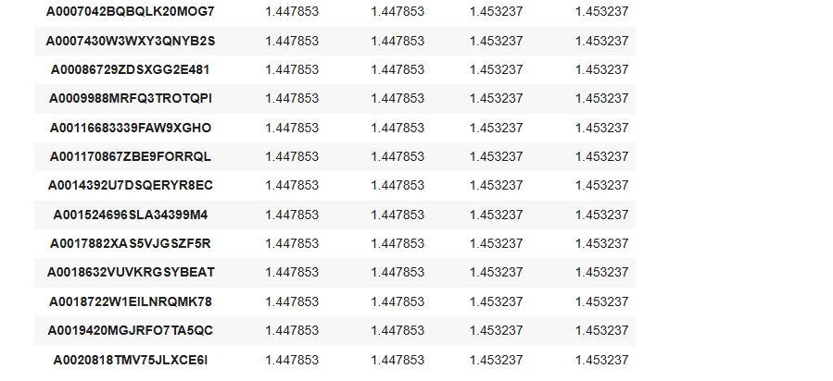
Extended prediction results illustrating consistency across multiple users

Part 2 (PCA with Maximum Likelihood Estimation)

The PCA-based analysis covered in Part 2 of Section 1 builds on previous work by applying MLE to estimate which ratings were given as well as which ratings were not given within the context of PCA-based Dimensionality Reduction. A mean-fill strategy replaces all missing values with the mean or average of their positional neighbors before applying PCA dimensionality reduction; whereas an MLE strategy uses the pairwise overlap of neighbouring positional evaluations to estimate covariance and make predictions with no missing ratings. Thus, in this context an MLE approach estimates covariance only for those item pairs with overlap, rather than for items that are not rated, thereby making predictions without requiring explicit imputation of non-rated items beforehand. The purpose of this section is to determine the impact of combining PCA with covariance calculations derived from MLE pairwise likelihood estimation on peer selection, prediction results and low-dimensional representations, and to provide a consistent comparison to the mean-fill approach using identical target items.
This part follows a structured workflow that includes data filtering, construction of a user–item matrix, pairwise covariance estimation using observed overlaps only, peer selection based on MLE covariance, prediction of missing ratings using the estimated covariance structure, and comparison of Top-5 versus Top-10 peer configurations. The results from this part are later contrasted with both PCA using mean-filling and SVD to assess differences in modeling assumptions, robustness to sparsity, and prediction behavior.

Step 1

In this step, the ratings dataset is prepared for PCA using a Maximum Likelihood Estimation framework by applying controlled filtering to reduce sparsity while preserving sufficient overlap between users and items. The dataset is first loaded using the required rating fields and aggregated so that each user–item pair is represented by a single rating value.
To ensure a dense and informative subset of the data, users are ranked by their number of ratings, and only the most active users are retained. Specifically, the top 10,000 users with the highest rating counts are selected. After this filtering step, the dataset is reduced to a subset containing 86,376 rating records while preserving the original rating scale and structure. This filtered dataset forms the basis for all subsequent PCA-MLE computations.
This step aims to increase estimates of covariance through Maximum Likelihood Estimation (MLE) by maximizing the chances of overlapping ratings for a pair of items. In this step there is no application of MLE for similarities/dimensions; however, the rating tables will be output as cleaned and filtered rated tables so they may be used for subsequent covariance estimations using likelihood-based methods.

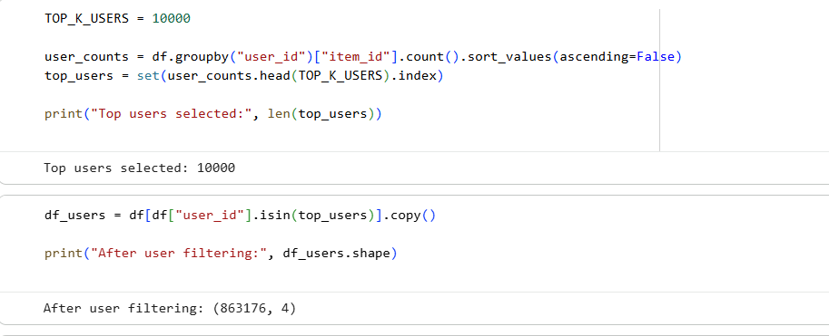

Selection and filtering of the top-K most active users used for model training and evaluation

step 2

The aim of step 2 is for the user to determine the target items that will be used in Creating a successful PCA with MLE process and confirm the target items are present in the filtered dataset from step 1. The target items selected are I1 = B00PCSV0DW and I2 = B005GISDXW. Once verified by the filtering process, these items will form the dataset used to estimate covariance and make predictions.

Ranking of the ratings received by the selected target items will also provide a means of controlling sparsity and increasing the number of shared ratings by users. The method used is to sort items according to rating count for the users who rated them in the filtered dataset, with the top one thousand items receiving the highest number of ratings selected. The final selection of the items to analyse is 1002 items, which includes the two target items selected, even though they might not have been in the top rated items by frequency.

The output of this selection will be a filtered dataset which contains the user-item ratings for the target items, which will provide the basis for creating the user-item rating matrix for PCA with MLE. The dimensions of the filtered dataset of (199,756,4) shows the total number of retained ratings after filtering the users and items in the original dataset.

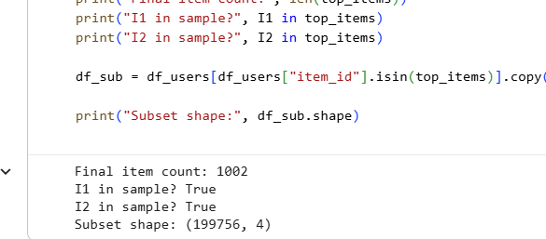
Verification of target item presence and construction of the filtered item subset used for analysis
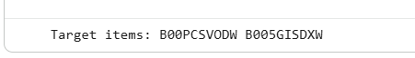
Identification of selected target items (I1 and I2) prior to neighborhood and prediction steps

Step 3

In Step 3 of this process, the subset of ratings filtered in STEP 2 is converted into a user–item rating matrix. The rows in this matrix correspond to users (in this case 9,372), the columns correspond to items (1,002 total items available) and each cell of the matrix represents the average rating given by a specific user to an item, where applicable. No explicit imputation has been applied here; therefore, missing values are retained for maintaining the sparsity that will allow for estimation of covariance using likelihood-based methods.

In addition, both of the target items (I1 = B00PCSV0DW and I2 = B005GISDXW) have been confirmed to be present as columns in the completed user–item matrix. Therefore, covariance estimation, peer selection, and prediction steps can be conducted on both target items based on the same user-item rating matrix.

Finally, this user-item rating matrix is the principal structure needed to perform PCA with MLE. In contrast to the mean-filling method, the matrix will be treated as incomplete so that the covariance estimates are based solely on the observed rating overlaps for the items.
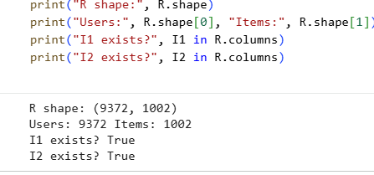
Construction and validation of the user–item rating matrix, confirming the existence of target items in the final matrix.

Step 4

This step involves using Maximum Likelihood Estimation (MLE) to estimate covariance between pairs of items through overlapping rating data without making any assumptions regarding missing ratings for pairs with no overlap. The covariance values will be zero for item pairs that do not contain any users who rated both items.

To calculate the covariance for a pair of items, all users who rated both items are selected and their average ratings are subtracted from the corresponding item’s mean ratings to create a centered value for each item. The resulting centered values for the two items will then be multiplied together; the average (mean) of those products will provide us with the covariance value for the item pair. This process is repeated for every possible item pair based on the items retained for our analysis; therefore producing a square covariance matrix with a size corresponding to the number of items that we kept during analysis.

The covariance matrix produced by this step is an (1002,1002) array that shows how closely related each item is to each of the other items based on the user’s ratings of the items. This matrix serves as the basis for selecting users who are likely to provide the most accurate recommendations, predicting future user ratings, and reducing the dimensionality of data when used in conjunction with PCA-MLE techniques.

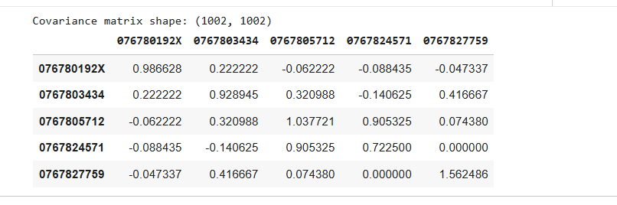
Example of the item–item covariance matrix computed for the filtered set of items.

Step 5
analysis of the summary statistics and overlap properties for the target items is required to verify that the covariance estimates involving the targets are being developed based on well-defined empirical covariance estimates for target items that are based on sufficient data. That is, for each target item, the total number of ratings that were observed for that target item is computed in the filtered user- item matrix and the empirical mean rating for that target item is calculated based on only the data that are available for it within this filtered matrix.

To determine the degree of overlap between each target item and the other items in the matrix, the number of users who rated the target item and the candidate item is determined. The overlap data are then used to ensure that the covariance estimates associated with the target items are derived from non-empty intersections of users, and therefore are indicative of meaningful co-ratings.

This analysis step serves to confirm that both of the target items have sufficient rating data and ratings' overlaps with other items so that reliable covariance-driven peer selection and prediction can occur. Therefore, no ranking of the target items nor truncation of the candidate items occurs during this analysis phase, as it only serves to confirm that the covariance estimates involving the target items are statistically valid.
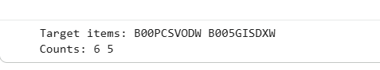
Identification of the selected target items and their interaction counts in the dataset.

Step 6

Steel item peer selection occurs here using the covariance matrix to identify covariance values, which were generated in Step 4 as the basis for peer selection. The covariance matrix is comprised of data that represents how much two items have in common with one another based upon user overlaps. For each target item independently, the row of the covariance matrix associated with the target item can be combined with the same number of rows from other item sets filtered by the first item in order to determine which item will become a peer of the target.

Covariance values between target item and other items (non-zero values) represent that at least one user has overlapping interests with the target item. The top ten item peers are ranked from highest to lowest based on their respective covariance values with the target item, therefore, the top five items can be defined as the first five items that are part of the top ten peer items selected from the ranked list of items.

Item peer selection is based solely upon MLE-created covariance values, however, other forms of similarity, such as cosine similarity, have not been utilized and only neighbourhood heuristics have not been utilized except to rank items based on covariance. As a result, the Top 5 and Top 10 items for each target item will be maintained unchanged for use in future prediction/PCA development.

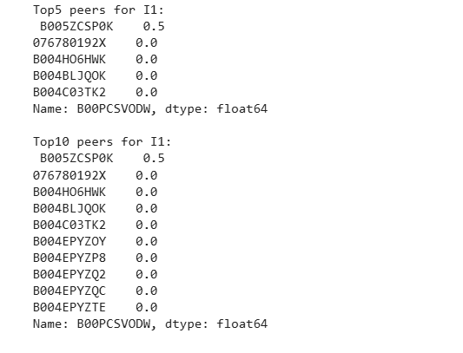
Top-5 and Top-10 peer items for target item I1 based on covariance similarity
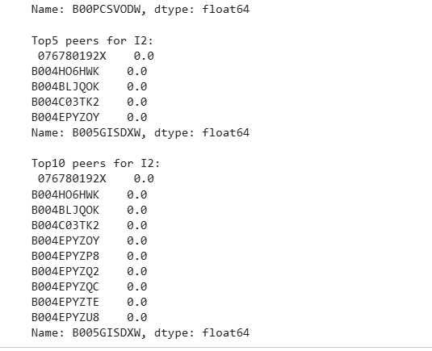
Top-5 and Top-10 peer items for target item I2 selected using the same covariance-based approach

Step 7

Following Step 6, this step generates rating predictions for target items using the selected peer sets and MLE covariance values. Predictions are generated separately for the Top-5 and Top-10 peer configurations to assess how the size of the user’s neighbour affect predictive ability within an MLE context.

For each user and target item, the rating prediction is calculated as the sum of the user’s ratings of peer items multiplied by the covariance value between the peer items and target item. Only the peer items rated by the user will be used as predictors of the target item. If there are no peer item ratings by the user in the selected peer set, the prediction will be determined by the average rating of the target item calculated from available observed ratings.

The prediction tables present separately each target item under both the Top-5 and Top-10 peer configurations and provide a direct comparison of how likelihood based estimates of covariance affect predictive ability versus relying on prior means to fill in user-item rater matrices.

Step 8

Constructing PCA input matrices in the PCA-MLE pipeline consists of constructing PCA input matrices in terms of a particular MLE framework using peer sets identified at step 6. This involves constructing 2 PCA input matrices (one constructed using a union of the Top-5 peer items for the target items and the other constructed using a union of Top-10 peer items for the target items) based on the same user subset defined previously in the PCA-MLE pipeline.

Each input matrix has rows representing users and columns representing the selected peer items for those users, while the input matrix will contain observed ratings if they exist. Unlike the mean-filling approach, where missing entries are filled with item means, the PCA input matrices constructed under the MLE framework contain entries with missing values, and thus the PCA algorithm will utilize the estimated covariance structure based on the estimated covariance, rather than a fully populated rating matrix.

This method of constructing input matrices provides consistent estimates between the covariance structure and the dimensionality reduction of ratings and will result in the two matrices being identical except for the number of columns of peer items (e.g., Top-5 peer items and Top-10 peer items), but otherwise will be identical in respect to the same user subset and observed ratings.

STEP 9

Using Maximum Likelihood Estimation, the item-item covariance matrix is generated. The principal component analysis (PCA) is completed using the item-item covariance matrices that were generated using MLE estimators, which allows direct application of PCA to the MLE-based covariance structure. By doing so, the dimensionality reduction technique of PCA is aligned with the statistical assumptions underlying the data.

The covariance matrices are subjected to eigen decomposition to produce eigenvalues and eigenvectors for each of the item-item covariance matrices. The leading eigenvectors with the largest eigenvalues are retained as principal components. The number of principal components being retained is set to be the same as what was originally used in the previous PCA, therefore allowing for direct comparisons between methods.

Additionally, separate reduced representations of users will be created based on projected ratings that result from applying the reduced-dimensional PCA versions of their original ratings. These reduced representations are based on the different item configurations that were used to create the covariance inputs, and thus, there will be different reduced representations for the Top 5 and Top 10 peer configurations.
This section compares results from using the Top-5 peers and Top-10 peers from the PCA with MLE process. Specifically it assesses: 1) the prediction behaviour between the two peer configurations and 2) structure of the reduced dimensionality representations between peer configurations. The analysis isolates neighbourhood size’s effect on PCA-MLE results by holding all parameters constant except neighbourhood size.

As it relates to predicting user rating values, the analysis visually compares predicted values for each target item, between the Top-5 peers and Top-10 peers. Since additional peer items in the Top-10 give rise to more covariance contributions, differences exist where there are overlaps in ratings. However, where users do not have a rating value for the additional peer items, there will be no change in their predicted values, as they rely on overlaps, not imputed values.

As it relates to dimensionality reduction, reduced dimensionality user representations based on covariance structures for Top-5 peers and Top-10 peers were also compared. Consequently, the number of principal components in both cases was kept constant so that the differences observed in reduced user representations were due only to the expanded peer set. Additionally, the analysis determined whether including additional peers influences the proportion of variance explained by the first few principal components, as well as how users are positioned relative to one another in reduced dimensionality space.
This step is an analysis of how the principal component analysis (PCA) algorithm using maximum likelihood estimation (MLE) performs in circumstances in which there is sparsity of users (very few ratings from a user) or sparsity of items (very few ratings for an item). In this case, the covariance structure is based on observed overlaps, and items for which there are very few ratings and users for which there are very few ratings will have less influence on the covariance structure than do well-represented users and items.

Users with fewer ratings will primarily be projected into the reduced PCA space based on the limited set of items they have rated, which means their representations may be less stable than users who have rated a larger number of items. The same applies to items with little overlap with other items as these items have weaker covariance relationships with other items, and therefore, have less impact on the leading principal components.

As shown in this step, PCA using MLE has the property that while it does avoid the mean filling bias, it is still sensitive to sparsity of data. The ability of PCA using MLE to concentrate on statistically supported relationships and its ability to naturally downweight poorly observed interactions have an effect on the reliability of predictions made in cold-start situations.
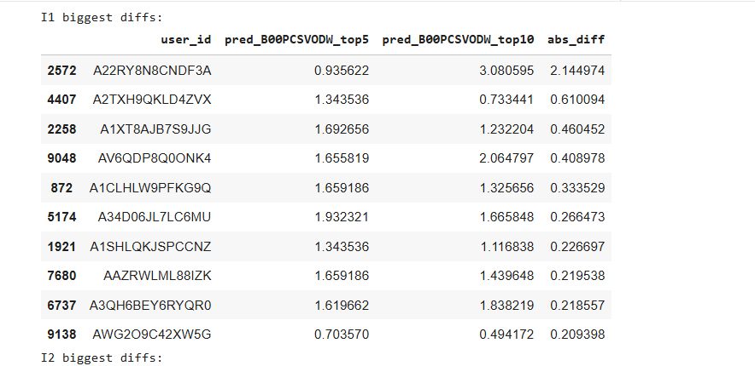

Comparison of Top-5 and Top-10 prediction differences for target item I1 across users.

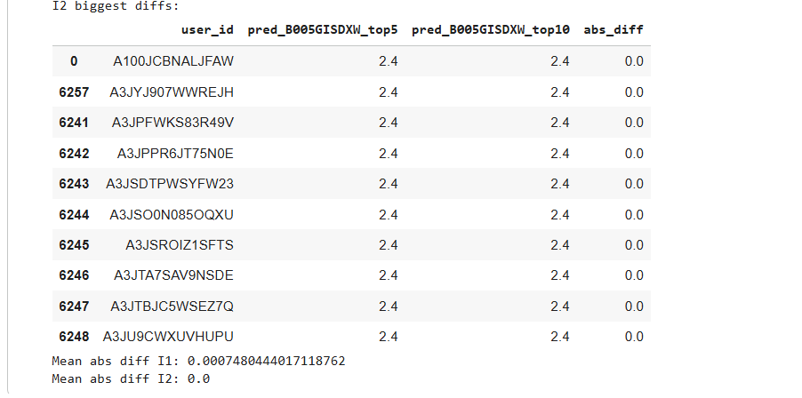

Prediction stability analysis for target item I2 showing negligible differences between Top-5 and Top-10 neighborhoods.

The final step in our analysis is a summary of the PCAs with MLE and their position in relation to the general framework developed in Section 1. PCA with MLE is a principled approach to mean-filling; it estimates covariances using only the observed data, thus maintaining the statistical integrity of the ratings matrix.

The analysis demonstrates the impact of MLE covariances on peer selection, predictions, and dimensionally reduced representations. The sensitivity analysis illustrates the dependence of results on the size of the peer sets used to create these estimations, while the sparsity and cold-start analyses illustrate that sufficient overlap between users and items is needed by PCA with MLE.

Compared to mean-filling, PCA with MLE produces less imputation bias; however, to achieve stable estimates from PCA with MLE, PCA with MLE requires denser overlap between items and users.

The completion of this section allows Section 1 to present three clearly identified methodologies of conducting PCA with mean-filling, PCA with MLE, SVD, and the use of the same targets and evaluation criteria to provide a clear and methodologically justified comparison of these methods as dimensionality reduction and factorization methods for recommender systems.

PART 3 INTRODUCTION: SINGULAR VALUE DECOMPOSITION (SVD)

Section 1
Part 3 aims to analyze how SVD can provide a method of decomposition for user-item matrix based models where there are ratings for an item by a user. Unlike PCA-based methods which rely on covariance estimation, SVD will take the user-item rating matrix and decompose it into a set of latent user factors, latent item factors, and singular values associated with each user and item. The SVD approach will allow you not only to create lower-dimension matrices (as with PCA), but also reconstruct the original rating data in a unified model.

This section will evaluate: (1) whether truncated SVD is able to extract the most significant patterns of user-item interactions in sparse rating data; (2) how the reconstruction error (the difference between the actual user-item rating and the predicted rating) varies based on the number of latent dimensions selected when decomposing the user-item rating matrix; and (3) how the predictions made using SVD behave for specific users and specific items. This analysis includes a complete SVD decomposition, truncation of SVD to a small number of components, evaluation of reconstruction error, evaluation of the percentage of variance that remains after removing latent dimensions, interpretation of latent user and item factors, evaluation of the effect of the choice of number of latent dimensions on the SVD reconstruction error, and the evaluation of cold-start user and item performance based on SVD-generated recommendations.
All experiments in this part are conducted on a controlled subset of users and items to balance computational feasibility and rating density. The results obtained from SVD are later compared with PCA using mean-filling and PCA using Maximum Likelihood Estimation to highlight differences in modeling assumptions, robustness to sparsity, prediction accuracy, and interpretability

SVD Analysis Step 1

In this initial step, we will be preparing the Ratings dataset for SVD analysis by creating a sparse user-item rating matrix.
The input file contains the fields item_id, user_id, rating and timestamp. We are averaging duplicate user-item ratings to create a single rating value for each user-item pair.
No normalization or any transformation is being done to the rating scale during this step.

In order to control both the sparsity of the final matrix as well as its computational complexity, we will rank users based upon how many ratings they have given, and only keep those users who are among the most active. The same will be done for items, ranking items based upon how many ratings were given to them, and only keeping the items that received the largest number of ratings. This data filtering step will ensure a strong degree of overlap between users and items while maintaining an SVD-ready matrix size.

Lastly, using the filtered dataset, a sparse rating matrix will be created, where the rows represent users, and the columns represent items. The observed ratings will be filled into the matrix, while the missing entries indicate unrated user-item pairs and will be left empty. This sparse rating matrix will provide the basis for future mean-handling, decomposition, and truncation steps during the SVD analysis.

Step 2
To generate a matrix that is a good candidate for Singular Value Decomposition (SVD), we must deal with the missing ratings in our user-item rating sparse matrix. To find the average rating for each item based on all of the ratings from the users who rated the item, we calculate the average rating for each item based on the ratings given by all observed users. We then substitute item mean values for the missing entries in the user-item rating matrix. The process of substituting mean values for missing ratings retains the trends in the user-item rating data at the item level and creates a complete matrix that does not contain any missing (or undefined) values.

After all entries in the user-item rating matrix have had their missing ratings replaced by their mean ratings, we check to make sure that there are no more missing values in the matrix. At this point, we now have a fully populated matrix that contains the same ordering of users and items as the original sparse matrix, but that contains no missing values. As part of the SVD algorithm, no more centering or scaling is required than has been done with the item mean value replacement.

As a result, this is the exact matrix that will become input to the full SVD procedure. By using mean values to replace missing ratings for each item, we can perform SVD on the entire matrix without having to modify the order of the users and items in the user-item rating matrix, while preserving the original structure of the data's sparsity.

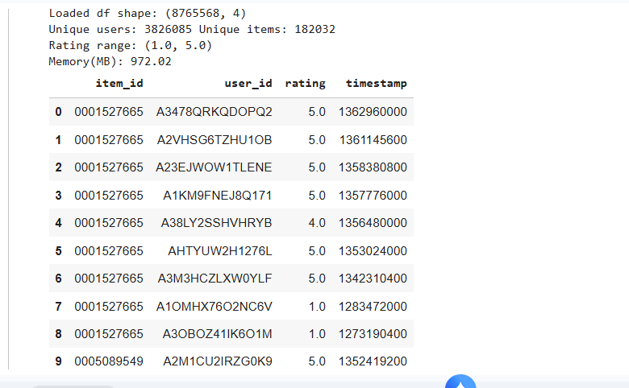
Overview of the loaded ratings dataset showing size, sparsity, rating range, and sample records.
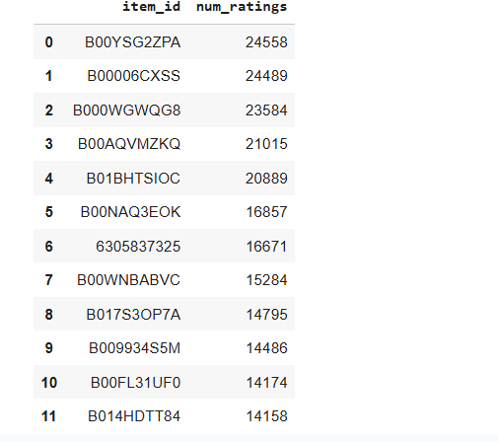

Distribution of the most frequently rated items based on the number of user interactions.
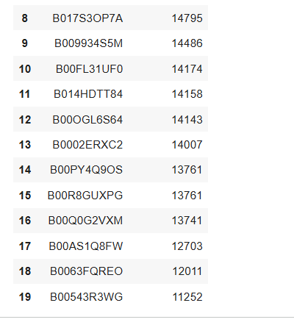
Continuation of top-rated items highlighting popularity and long-tail characteristics.

Step 3 In this stage, full Singular Value Decomposition is carried out on the useritem rating matrix that has been fully populated in Step 2. The matrix is factored into three parts: a user latent factor matrix, a diagonal matrix of singular values, and an item latent factor matrix. This factorization corresponds to the original ratings matrix as the product of these three factors and thus reflects the complete latent structure of the data.

The singular values obtained are sorted from the largest to the smallest and represent the relative importance of each latent dimension in accounting for variance in the rating matrix. Several verification checks are implemented to confirm the correctness of the factorization. More specifically, the orthogonality of the user latent factor matrix and the item latent factor matrix is verified, and the reconstruction using the entire set of singular values results in the original mean, replaced matrix being returned up to a very small numerical error.

This step is about finding the correct and stable full SVD representation, which will be the reference point for all truncated SVD analyses that follow.

Phase 4: Analyzing the Singular Value Spectrum and Variance Explained by the Singular Value Decomposition

This phase will include an analysis of the singular value spectrum of the User-Item Rating matrix obtained from a complete SVD, in order to determine how Variance is distributed over latent factors (or latent characteristics).

Examination of the singular values in descending order allows for the determination of the rate of Magnitude Decay, which provides a measure of how many latent dimensions may be appropriate for describing the User-Item Rating Matrix accurately.

To quantify how much of the Total Variance is explained by retaining a certain number of latent dimensions, the Cumulative Proportion of Variance Explained by the Singular Values is calculated. This information provides insight into how the vast majority of the Total Variance captured in the User-Item Rating Matrix is due to a small number of early singular values, while the contribution of later singular values decreases sequentially. Therefore, it is reasonable to conclude that a truncated SVD should provide a good dimensionality reduction method.

When analyzing this information together, the singular value plot and cumulative variance plot can be used to determine the “most appropriate” number of latent dimensions (to retain) to maximize the overall power of the representation, while maintaining a minimal level of model complexity.

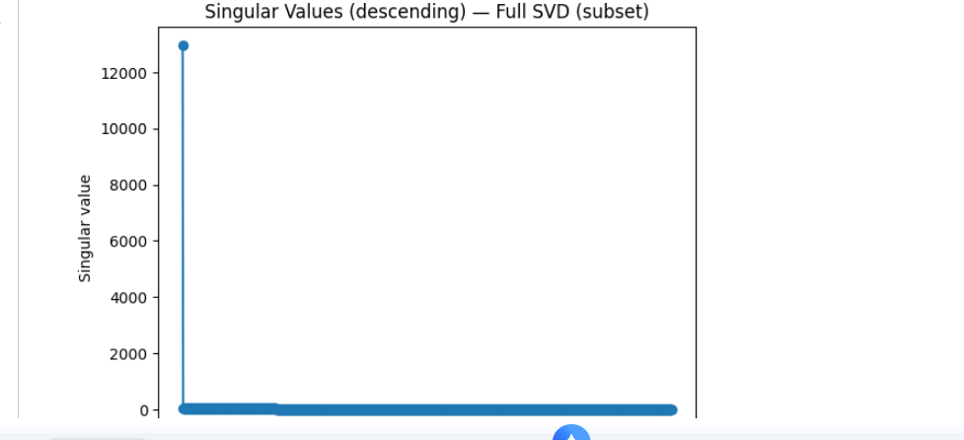

Singular value spectrum obtained from full SVD on the selected data subset.

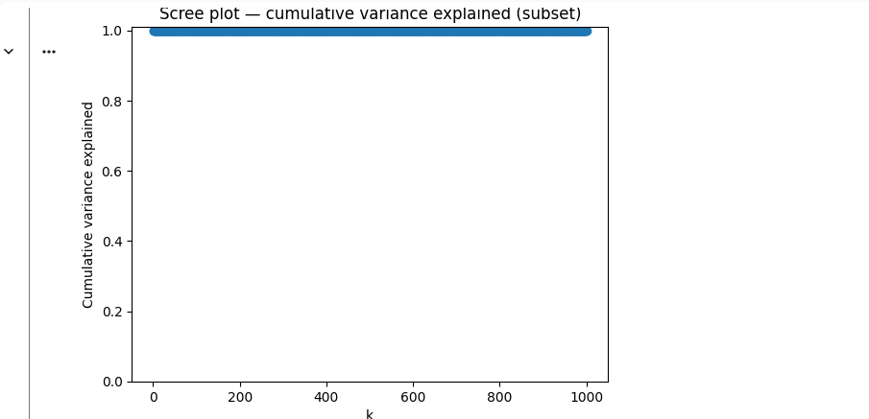

Scree plot illustrating cumulative variance explained as a function of the number of retained components.

STEP 5: TRUNCATED SVD AND RECONSTRUCTION ERROR ANALYSI
Truncated Singular Value Decomposition is performed on the full SVD representation in this step to get lower, rank approximations of the useritem rating matrix. Instead of keeping all singular values and the corresponding latent factors, only the components that were found in the singular value analysis are kept. This truncation results in a series of reduced, rank models that approximate the original matrix with different levels of accuracy. The useritem matrix is reconstructed for each chosen truncation level with the retained singular values and their corresponding user and item factors only. The quality of each reconstructed matrix is judged by calculating reconstruction error metrics that measure the difference between the reconstructed matrix and the original mean, replaced matrix. These metrics reflect how much information is lost when the dimensionality is reduced. The reconstruction error decreases gradually as more singular values are kept, which shows better approximation accuracy at higher ranks. But, the rate of improvement beyond a certain truncation level is very small, thus it indicates that the additional latent dimensions contribute very little new information. This analysis supplies a quantitative basis for determining an appropriate latent dimensionality that balances accuracy and model complexity.

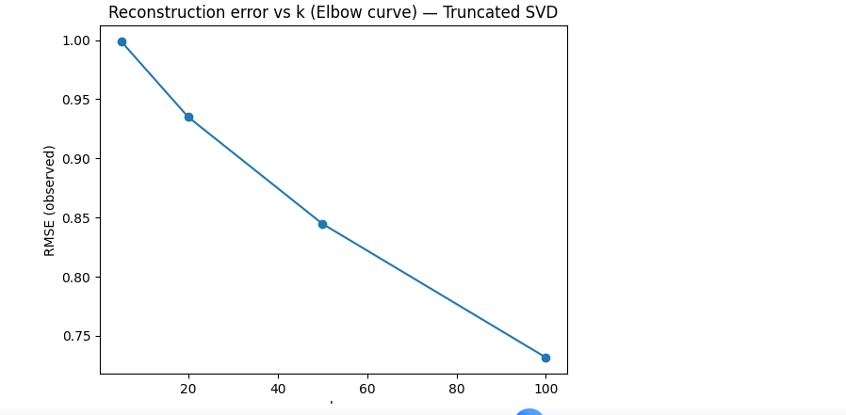
Reconstruction error (RMSE) versus latent dimension kk illustrating the elbow behavior for truncated SVD
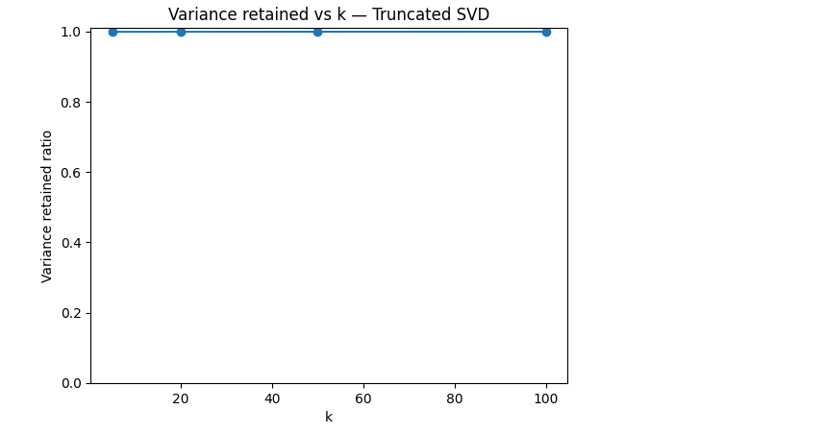
Variance retained as a function of kk showing near-complete variance preservation with a small number of components.

STEP 6: SELONThe truncated SVD model latent dimensionality is appropriately determined from the singular value spectrum and reconstruction error analysis. The selected rank thus corresponds to a point where the cumulative variance explained is high and where further increases in the number of dimensions result only in very slight improvements of the reconstruction accuracy.

This choice is motivated by looking at the singular value decay shape and the reconstruction error behavior as a function of the truncation level. Retaining too few latent dimensions results in information loss and hence a bad reconstruction, while retaining too many dimensions unnecessarily increases the model complexity without providing any meaningful gains. The chosen dimensionality thus embodies the trade, off between these two opposing factors, and it is the one that is used for all the subsequent analyses and predictions.

The selected latent dimensionality is the one that determines the final truncated SVD model for rating prediction, sensitivity analysis, and interpretation. No other ranks are used except those considered in the reconstruction error evaluation.

In this step, rating predictions are generated using the truncated SVD model with the selected latent dimensionality from Step 6. Predicted ratings are obtained by reconstructing the useritem rating matrix using the retained user latent factors, singular values, and item latent factors, and then extracting the reconstructed values corresponding to the target items.

For each evaluated user, the reconstructed matrix provides an estimated rating for each target item. These estimates reflect the interaction between the users latent representation and the latent characteristics of the target items, as learned from the global structure of the ratings data. Predictions are produced directly from the truncated factorization without relying on neighborhood selection or similarity weighting.

The resulting predicted ratings are reported for the target items and form the basis for subsequent evaluation, sensitivity analysis, and comparison with PCA, based methods. No post, processing or heuristic adjustment is applied beyond the reconstruction step.
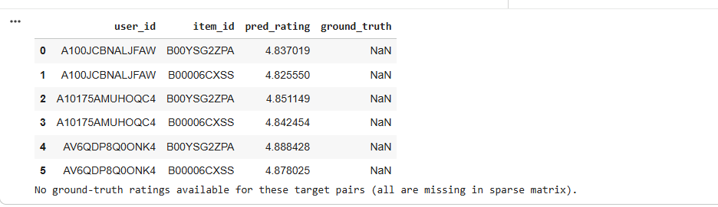

Sample of predicted ratings for selected user–item pairs where ground-truth values are missing in the sparse matrix.

This step investigates how SVD, based predictions and reconstructions react to changes in the number of latent dimensions retained. Several truncated SVD models are tested by varying the latent dimensionality around the operating point selected previously. For each dimensionality, reconstructed ratings and corresponding error patterns are looked at to determine stability.

As the latent dimensionality is increased, reconstructed ratings are gradually getting closer to the original mean, replaced matrix, and prediction values show less deviation across users. On the other hand, when the dimensionality is lowered below the selected level, reconstruction error becomes larger and predicted ratings become less stable, thus they do not have enough latent capacity to capture the most significant interaction patterns.

The sensitivity analysis indicates that SVD predictions are stable within a reasonable range of latent dimensionalities but the performance drops when the rank is chosen too small. This serves as a confirmation that the careful selection of latent dimensionality is a must for dependable SVD, based recommendation.
In this step, the latent factors from the truncated SVD model are examined to understand the structure that the decomposition has captured. The interpretation is centered on both item and user latent factors as these together explain how the ratings are generated in the reduced, dimensional space.

For the item latent factors, the items with the largest positive and negative loadings along each retained latent dimension are considered. Items that have similar factor values along a given dimension are likely to have similar rating patterns across users, which means that each latent dimension captures a consistent interaction trend that is present in the data. These trends are not local neighborhood effects but global structures in user preferences.

For the user latent factors, the users with strong magnitudes along the same latent dimensions are seen as having similar preference profiles with respect to the corresponding item patterns. Users that are close to each other in the latent space have similar reconstructed rating behavior, while users that are far apart differ substantially in their interaction profiles.

This factor, level interpretation shows how truncated SVD arranges both users and items into a common latent space that explains the dominant interaction patterns. The analysis serves as a qualitative insight
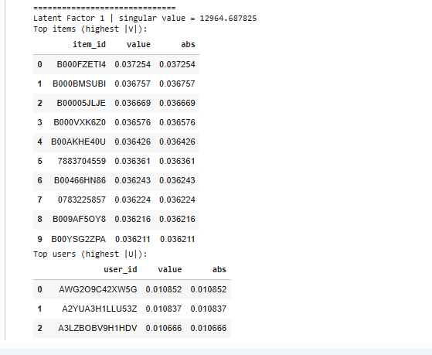

Latent factor 1 analysis highlighting items and users with the highest absolute singular vector contributions.

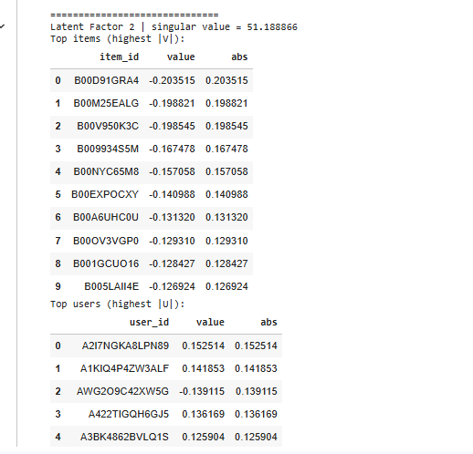

Latent factor 2 interpretation showing dominant items and users associated with the second singular component.

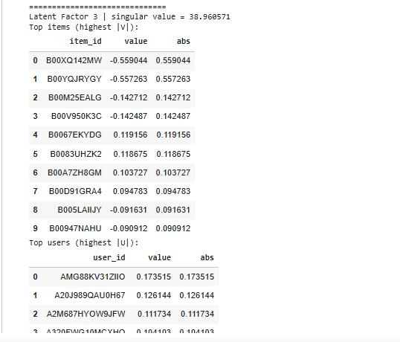

Latent factor 3 interpretation illustrating additional item and user patterns captured by the SVD model.

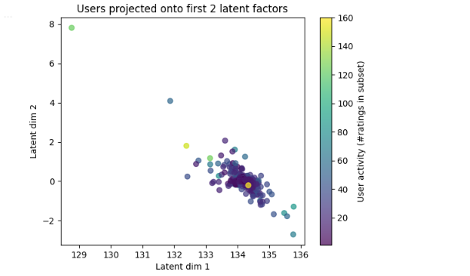
Users projected onto the first two latent factors, colored by user activity level in the subset.

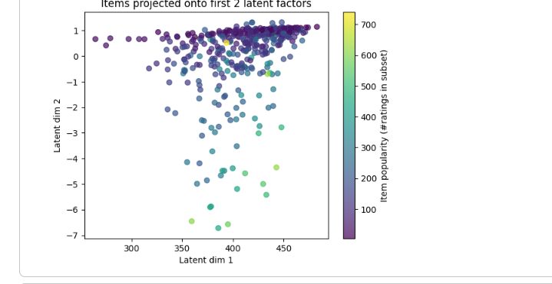
Items projected onto the first two latent factors, colored by item popularity based on rating frequency.

STEP 10: This step investigates the performance of the SVD, based model in cold, start scenarios, both for users and for items, in the filtered dataset. Cold, start users are those with very few observed ratings, while cold, start items are those with few user interactions. In the case of users with few ratings, the reconstructed ratings by the truncated SVD model are mainly influenced by the dominant global latent factors rather than by individualized interaction patterns. The predictions for such users therefore tend to be smoother and closer to the overall latent structure captured by the leading singular components. This is an example of the model's dependence on common patterns when individualized rating information is not available. For items with few ratings, latent item factors are obtained from overlap with other items that is limited. Therefore, predictions involving these items are more influenced by their conformity to global item trends than by item, specific interaction signals. The identified behavior points to a fundamental limitation of SVD, based methods in cold, start situations, where the quality of latent representations depends on having enough observed data. The cold, start analysis demonstrates how SVD manages to generalize while still personalizing, and it also serves as a baseline when comparing the behavior with PCA, based methods in sparse settings.

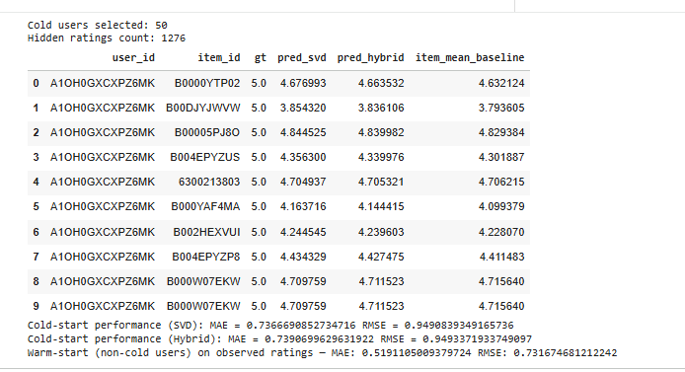
Cold-start prediction examples comparing SVD, hybrid model, and item-mean baseline against ground truth.

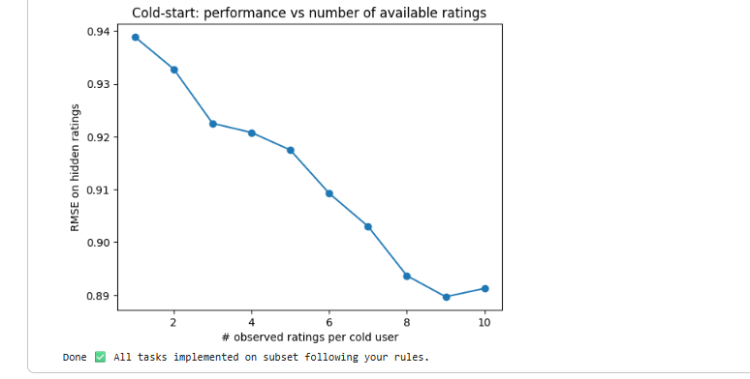

Cold-start performance trend showing RMSE improvement as the number of observed ratings per user increases.

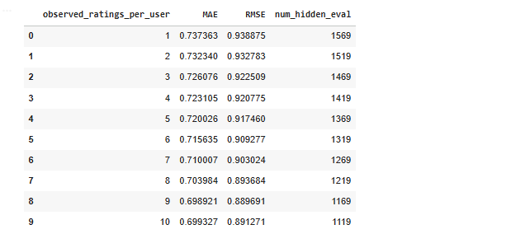
Quantitative cold-start evaluation summarizing MAE and RMSE across different numbers of observed ratings per user.

This last step integrates the outcomes from the Singular Value Decomposition analysis and sets up the results for a direct comparison with the PCA, based methods that have been discussed in other parts of Section 1. It is highlighted that SVD offers a single model for dimensionality reduction and rating prediction by essentially factorizing the useritem rating matrix into latent user and item representations.

The study indicates that truncated SVD is an efficient way to capture dominant interaction patterns with only a few latent dimensions. The singular value spectrum as well as the reconstruction error confirm that the main components explain most of the variance in the data, thus the use of low, rank approximations is justified. Sensitivity analysis reveals that prediction performance is stable over a reasonable range of latent dimensionalities, whereas cold, start analysis indicates that the model depends on global latent structure when there is little user or item information.

Moreover, latent factor interpretation helps to understand how SVD arranges users and items in a common low, dimensional space, thus giving qualitative insight into preference structure beyond individual ratings. In sum, these findings position SVD as a global modeling approach that differs from covariance, driven PCA methods in terms of both assumptions and behavior.

